Experiment 1: Extraction of a Three-Component Mixture
You should read, and understand, the section on extraction in the Appendix before the laboratory
This experiment has been chosen to illustrate the isolation of compounds from a mixture by using two immiscible solvents, as well as to introduce you to the separation techniques in organic chemistry and the concept of solubility.
Acetanilide, Aspirin, and Urea all have unique solubility properties when exposed to acidic or basic environments. Acetanilide is widely used as an intermediate for the synthesis of pharmaceuticals and as an additive in hydrogen peroxide, varnishes, polymers and rubber. Aspirin is the wonder cure medicine commonly branded as Tylenol and sold all across North America. And finally, urea is a well-known compound found most commonly in urine and mainly produced in the liver.
Often, an extraction method is used as the first step in purification. For example, a desired compound can be obtained from a mixture or from a natural source through extraction. The compound obtained is impure, as it is mixed with minor components of another compound; or, when there is a mixture of two or more components and only one of the components is desired, then it is impure. The undesirable components are considered impurities. Any remaining impurities are then removed by a method of final purification—these may include distillation or recrystallization. Recrystallization is a method of purifying impure solids, while distillation is a method of purifying impure liquids.
Solvents and Solubility
Solvents play a large role in organic chemistry experiments and are commonly classified in terms of polarity. The polarity of an unknown compound is estimated by comparing its solubility in solvents with “known” polarity. For instance, most inorganic ionic salts, and the salts of organic acids and bases are soluble in water. This brings us to solubility by reaction, which is common in organic chemistry. Organic acids and bases, as with inorganic analogues, react together to give water-soluble salts. In general, the functional group of a compound plays a significant role in determining solubility in a solvent.

These functional groups typically increase a compound’s polarity:
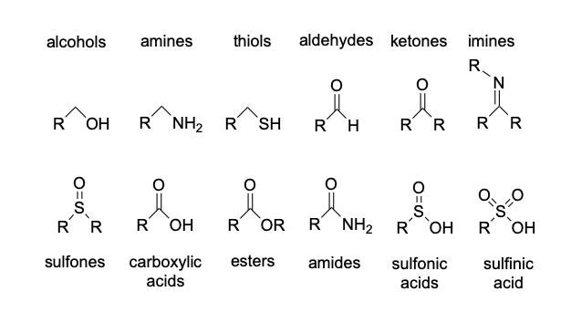
Solubility tests are extremely useful in determining the possible functional groups present in an unknown compound. Small amounts of the unknown are used, but the information gained in a short period of time is invaluable. A “solubility chart “is shown below. It is necessary to understand the solubility based on functional groups and to be able to reach appropriate conclusions about structures of unknown compounds based on solubility results
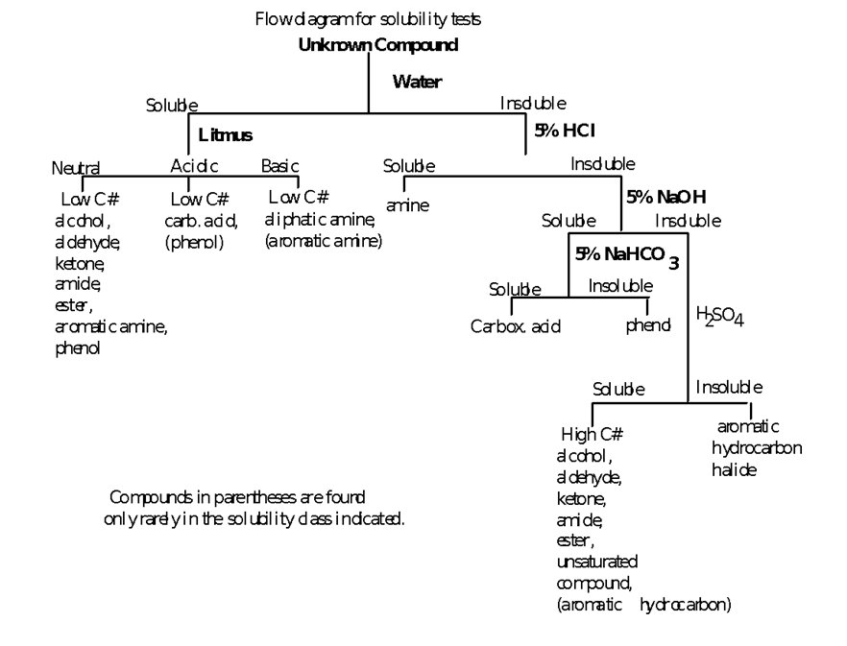
Solubility Chart
Organic compounds containing functional groups capable of forming hydrogen bonds with water display greater solubility in water and other polar solvents than those without such functional groups, such as -COOH, -SO₃H, -OH, -CHO, -NH_{2.} Regardless of the presence of these hydrophilic groups, the limiting factor for the solubility of an organic compound in water is the number of carbons in its structure: generally, molecules with greater than five or six carbon atoms will not be able to dissolve in water.
You may have noticed that both an ionic salt and a small hydrophilic organic molecule are soluble in water. This could become a major issue when determining the identity of an unknown compound using the solubility test. To resolve this problem, an organic solvent such as diethyl ether or methyl tert-butyl ether (MTBE) can be used to distinguish between the two compounds. Due to the nature of its hydrocarbon structure, organic compounds will be soluble in the organic solvent, while the salt will remain insoluble. Non-polar and neutral compounds will be in the organic layer while ionic and polar compounds will be found in the aqueous layer.
Solubility by Reaction
Solubility by reaction is a common occurrence in organic chemistry. Just as an inorganic acid reacts with a base to produce a water-soluble salt and water, organic acids and bases also follow this same principle to give water soluble salts when reacted together. For example, molecules possessing the basic organic functional group, -NH₂, are soluble in dilute acidic solutions:
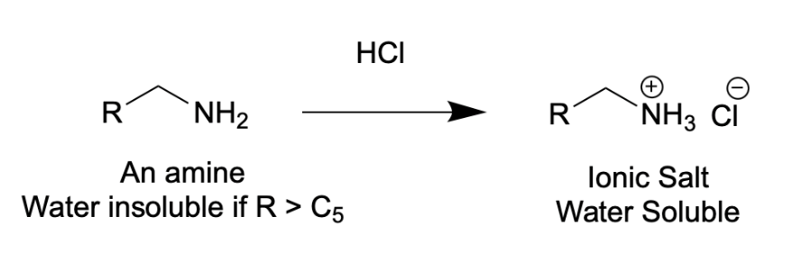
Likewise, compounds possessing acidic functional groups, such as phenols (C₆H₅-OH) or carboxylic acids (R-COOH) are soluble in dilute sodium hydroxide:
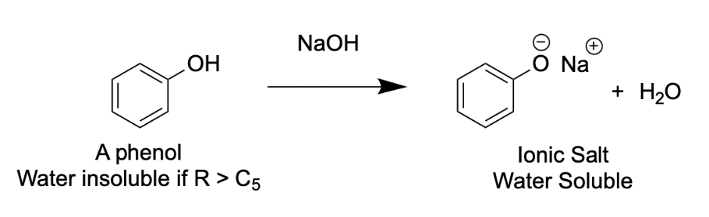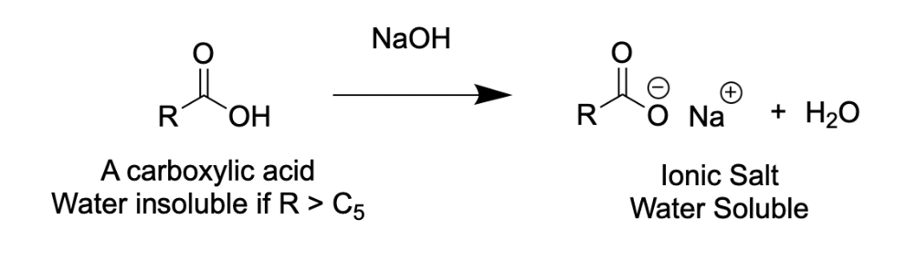
The -COOH, a strong acid, is also soluble in dilute sodium bicarbonate (weaker base):
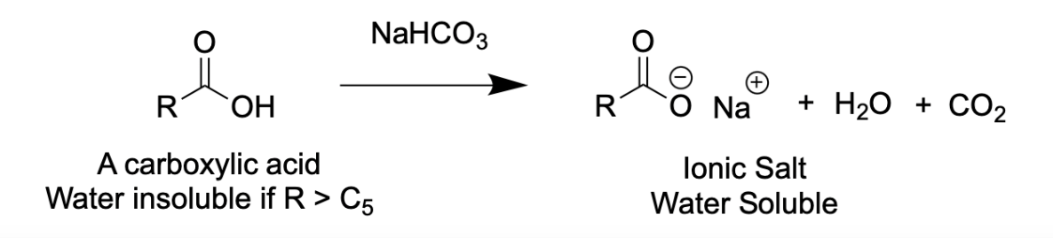
Polar compounds generally dissolve in polar solvents, and non-polar compounds in non-polar solvents (known as the “like dissolves like” concept). The rate of solution of a solute in solvents can also be increased by agitation (shaking or stirring). Finely divided solids usually dissolve faster than large chunks of solid due to their greater surface area. Often a solute appears insoluble, but if left to stand, can later be found to be slowly soluble.
SOLVENT | BOILING POINT | FREEZING POINT | POLARITY
Petroleum ether | Various ranges |  | N
Cyclohexene | 81 | 6.5 | N
Carbon tetrachloride | 76 | -23 | N
Benzene | 80 | 5.5 | N
Chloroform | 61 | -64 | I
Methylene chloride | 40 | -97 | I
Acetone | 56 | -95 | P
Ethanol | 78 | -117 | P
Methanol | 65 | -98 | P
Water | 100 | 0 | P
N=non-polar I=intermediate polarity P=polar

A mixture of an acid, base and neutral compound could be separated based on the change in solubility that occurs once the compound has been deprotonated or protonated. Organic acids are often insoluble in water and soluble in slightly polar organic solvents such as ether. However, bases can deprotonate the organic acids to form ionic salts, which are soluble in water but insoluble in ether (solubility by reaction). Strong organic acids are strong proton donors and therefore are the easiest to deprotonate. They will react readily with both strong and weak bases. In contrast, a weak acid is a poor proton donor and can therefore only be deprotonated by strong bases. The acids can be recovered by acidification, which will protonate the compound, allowing it to precipitate out of the aqueous solution and be filtered by vacuum filtration. Similarly, a water-insoluble organic base can be protonated by an acid to form an ionic salt, extracted into the aqueous layer and then recovered by the addition of a strong base. The neutral compound remains in the organic solvent and is recovered by evaporating the organic solvent.
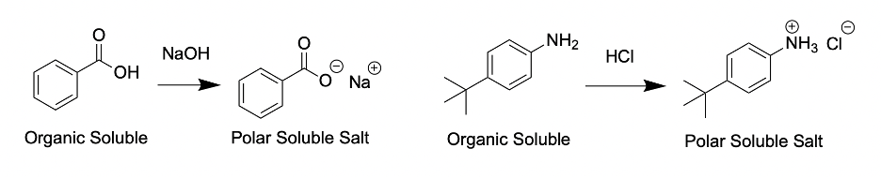
Figure 1. Using acid/base chemistry to change the functional groups on compound into charged species so the compounds become polar.
Data Sheet A has been completed for you, using appropriate reference books such as the Handbook of Chemistry and Physics (commonly called the CRC Handbook) or the Merck Index. You can find these resources under the “library resources” tab on the left side menu of our Quercus course page. You can also visit the library and the librarian can help you find the physical copies of these resources and give you further information on how to use them.
Data Sheet B should be done outside the lab and is due at the beginning of this lab. Your predictions for ten named compounds of known structure should be completed, according to the solvents used in the solubility chart given in the introduction. You do NOT need reference books for this - but you will have to think about the functional group structures contained in each compound!
EXTRACTION
In this part of the experiment, you will be separating acetanilide, aspirin, and urea from a mixture using different acid-base solubility properties and extraction, and in part 2, you will learn to remove impurities from acetanilide by recrystallization. You will then conduct a melting point determination of all three extracted compounds to determine the identity and purity of the separated components.
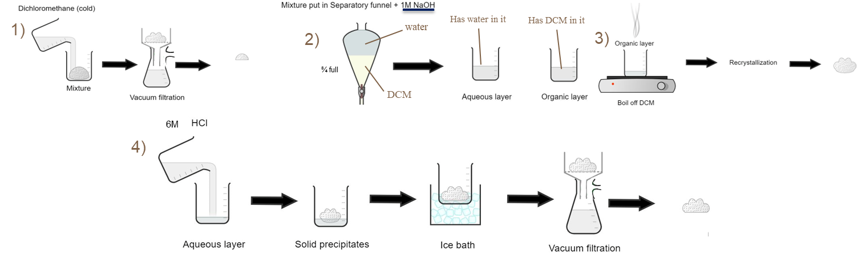
Figure 2. General steps for the isolation of each unknown compound
Procedure for Extraction:
- Measure out around 50 ml of Dichloromethane (DCM) in a 100 ml beaker and put a watch glass over the beaker to prevent evaporation of DCM.
- Obtain 3 grams of the pre-made mixture of 3 compounds (A, B, and C).
- Put the mix of compounds and previously measured 50 ml DCM into a 125 ml Erlenmeyer flask.
- Gently swirl the Erlenmeyer flask for about 1 min (What compounds will dissolve and what compounds will not? Refer to solubility rules and the functional groups of each compound to determine which solvents they will dissolve in.)
Extraction of Compound A
- Prepare an ice bath using a 250 ml beaker and put a 50 ml beaker inside containing 10 ml DCM collected from the 100 ml beaker.
- Set up a vacuum filter apparatus and wet filter paper sparingly with DCM using a pasteur pipette.
- Pour contents from the Erlenmeyer flask into the funnel.
- Add the remaining cold DCM into the Erlenmeyer flask to rinse out any remaining solids and then add to the vacuum filter.
- Dry the solid using a vacuum for approximately 2 minutes.
- Weigh the solid on a watch glass and calculate the percent recovery.
- Transfer the solid to plastic bag and save for recrystallization.
- Wash the 50 ml beaker for the next step.
Separation and Isolation of remaining Compounds B and C from Filtrate
- Prepare two, 100 ml beakers for the aqueous layer and for the DCM (organic) layer. Label the aqueous beaker compound C and the organic layer compound B.
- Transfer filtrate from the vacuum flask into a 250ml separatory funnel. (Use a glass funnel to prevent spillage)
- Rinse vacuum flask with 5 ml DCM from the 100ml beaker and add to the separatory funnel to ensure a good transfer of solution.
- Using the washed 50 ml beaker, take 25 ml NaOH (1M) from the TA fume hood using a graduated cylinder (or the beaker markings itself) and add it to the separatory funnel containing the filtrate and close the separatory funnel with a stopper. Shake the separatory funnel to mix and remember to vent frequently. Leave the separatory funnel on the ring stand until the solvents separate into two layers. (Which compound would be in the organic layer? Which one would be in the aqueous layer? How can you tell?)
- During extraction, it can be difficult to see the boundary between two immiscible colourless liquids. However, the boundary will usually become visible if a dark object is placed behind the liquids. Although two immiscible liquids often become cloudy when shaken, they become clear as the two layers start to separate.
- Determine if the bottom layer is aqueous or organic. (Which layer do you expect to be the top layer or the bottom? How would you tell if you didn’t look up the density?)
- After determining which layer is aqueous, extract the aqueous layer from the separatory funnel into the 100 ml beaker labeled Compound “C”, either through the stopcock or the top of the separatory funnel depending on if the aqueous solvent is the bottom or top layer.
- After extracting the aqueous layer into the 100 ml beaker labeled “C”, add another 25 ml NaOH (1M) into the now remaining organic layer inside the separatory funnel and shake. Remember to vent frequently. Leave for 2 minutes for solvents to separate into two layers and extract the layers into their respective beakers.
- Pour the organic layer into a 50ml beaker labeled compound “B”.
Extraction of Compound B
- Add 1-2 spatulas of magnesium sulfate into the 50 ml beaker containing the organic layer to dry it. Swirl gently. Stop adding drying agent once you see that there are free floating particles of the drying agent in your solution (may be less or more than the 1-2 spatulas).
- Weigh a clean 125 ml Erlenmeyer flask.
- Decant DCM into clean125 ml Erlenmeyer flask, leaving the magnesium sulfate behind while getting as much solution into the Erlenmeyer flask as possible.
- Set the decanted solution onto a hotplate, add 1-3 boiling chips, and set the temperature to 70°C - 80 °C to boil off DCM. If boiling is slow, increase the hot plate to 100 °C.
- Once the liquid has almost entirely evaporated off, pay close attention to the beaker to make sure that as much liquid has been evaporated without burning the product. The product should solidify and form a “fluffy” product very quickly towards the end.
- After DCM boils off (note the colour of the compound), record the weight of the Erlenmeyer to calculate percent recovery of the crude product.
- Transfer product to plastic bag, record its data on the product label, and keep for recrystallization.
Extraction of Compound “C”
- Wash the 50 ml beaker used for 10 ml DCM at the start of the experiment and set up an ice bath and chill 5 ml of deionized water in the beaker.
- In a 100 ml beaker containing the aqueous layer extracted from your separatory funnel, add 10ml HCl (6M). Make sure the solution is acidic by testing it with pH paper. Solid should precipitate out of the solution if done correctly.
- Cool mix in ice bath for 5 minutes.
- While waiting for the mix to cool, wash and set up the vacuum filtration apparatus.
- After setting up the vacuum filtration apparatus and chilling the mix, turn on the vacuum and pour the chilled solution into the funnel.
- Taking the previously chilled deionized water, use a new pipette to wash the solid on filter paper with 5 ml cold deionized water.
- Leave under vacuum for 5 minutes and mix solid on filter paper using glass rod to prevent water from being trapped in clumps.
- Weigh solid and record the weight of the solid; calculate the percent recovery.
- Save solid for melting point determination later.
NOTE: Remember to fully label ALL THREE compounds and hand in to your TA.
Pre-lab questions:
- How do you know which layer (aqueous or organic) will be on the bottom? On the top?

- Write the solubility by reaction equations for organic acids and bases.
- How can you make an organic acid soluble in water? How about an organic base? Once they are dissolved in water, how can you recover the original organic acid or base?
- How would you know that pressure is present in your separatory funnel when you are venting? How would you know that there was no more pressure?
- You are working with very concentrated hydrochloric acid. What are some dangers when working with concentrated acids? ​​
References:
(1) PubChem. Acetanilide. Nih.gov. https://pubchem.ncbi.nlm.nih.gov/compound/Acetanilide#section=Uses (accessed 2024-07-24).
(2) Murov, S. Experiments and Exercises in Organic Chemistry: A Challenge Oriented Approach; http://murov.info/orglab/11-e6.pdf.
(3) Experiments and Exercises in Organic Chemistry Lab Book. Murov.info. http://murov.info/orglab.htm (accessed 2024-07-26).

